–

|  |  |
| --- | --- |
| Single Page Application on Online shopping  MEAN FSD 8 Hour Code Capsule | Abstract  Online Shopping Application is a Single Page Application (SPA) that allow the Users to buy or sell the Items of their choices.  Developer  MEAN Full Stack Developer |

# Business-Requirement: An Overview

**The Online Shopping Application** allows user to view and order the items based on the Categories of the items which are updated by the Seller based on the availability of the product. Admin will have the control on all orders and items list**.** Below are the features of Online Shopping Application:

1. Sign Up option available if user is not registered before.

2. Items are listed based on Categories.

3. Options to view and update User Information on Home Page of the Application.

After login - Landing page (account page/profile page) -> view and update User Information

4. An option to view the previous Orders or sales.

5. Login for already registered User/Seller/Admin.

a. If logged in as User, the options to view or add the items into cart which are listed based on categories. On selecting the Cart option on Home Page it navigates and displays all the items in the cart and Invoices are made available.

b. If logged in as Seller, the options to view or add the new items or products, which can be added based on categories. On Click of Add Items, it allows to enter the product details and description and then it adds the product to the items list.

c. If logged in as Admin, the options to view the items ordered by the User and also knows about the newly added product by the seller. If the product do not meet the required criteria or fails to meet the certain regulations, admin have the control to remove the items from the List.

6. The user can add/edit address while ordering.

7. An option to cancel the order.

8. If online payment fails, the user can choose COD option and the product can be ordered.

# Technical Spec –Solution Development Environment

## Front End Layer

|  |  |
| --- | --- |
| **Framework(s)/SDK/Libraries** | **Version** |
| AngularJS | 1.5 or above |
| Bootstrap | 3.0 or above |
| CSS | 3 |
| HTML | 5 |
| JavaScript | **1.8 or above** |
| JQuery | **1.3** |

## Middle Tier Layer

|  |  |  |
| --- | --- | --- |
| **Technology** | **Framework(s)/SDK/Libraries** | **Version** |
| MEAN Stack | Node.JS | 6.x (Latest: 6.11.4) |
| Express.JS | 4.16.1 |

## Database & Integration Layer

|  |  |  |
| --- | --- | --- |
| **Technology** | **Framework(s)/SDK/Libraries** | **Version** |
| MEAN Stack | MongoDB/MySQL |  |
| NoSQL |  |
| Mongoose.JS | 4.12.1 |

## Ancillary Layer

|  |  |  |
| --- | --- | --- |
| **Technology** | **Framework(s)/SDK/Libraries** | **Version** |
| Source Code Management Tool | GIT | 2.14.2 |
| Build Tool/MEAN Stack | Grunt/Gulp | 1.0.1/3.9.1 |
| Dependency Management Tool/MEAN Stack | NPM | 4.x |
| Testing Tool/MEAN Stack | Jasmine |  |

## Deployment & Infrastructure

|  |  |  |
| --- | --- | --- |
| **Technology** | **Framework(s)/SDK/Libraries** | **Version** |
| Docker | - |  |
| Apache HTTP (XAMPP) | - |  |
| Node | - |  |
| Dependency Management Tool | NPM |  |

## Editors

|  |  |
| --- | --- |
| **Name** | **Version** |
| Adobe Brackets |  |
| Sublime Text |  |
| Atom Editor |  |

# Wireframes

**User SignUp page for buyer sign-up**

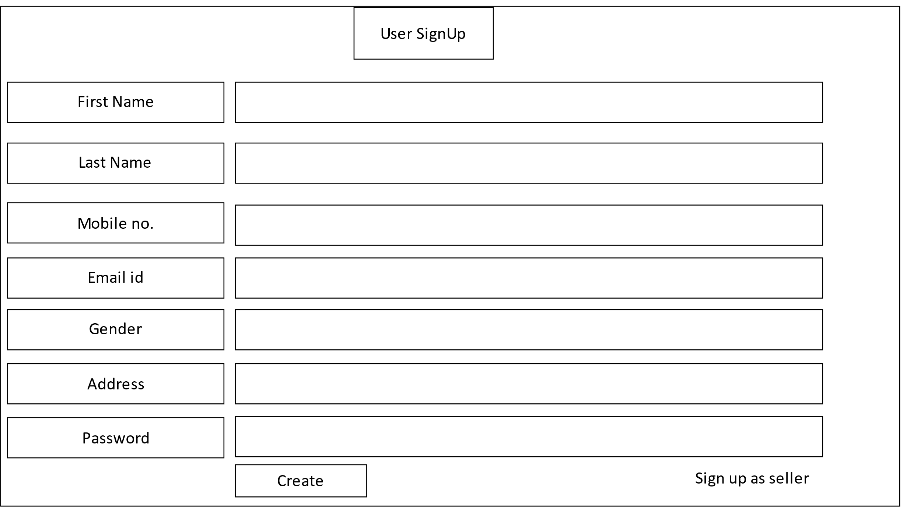

**User Signup page for Seller sign-up**

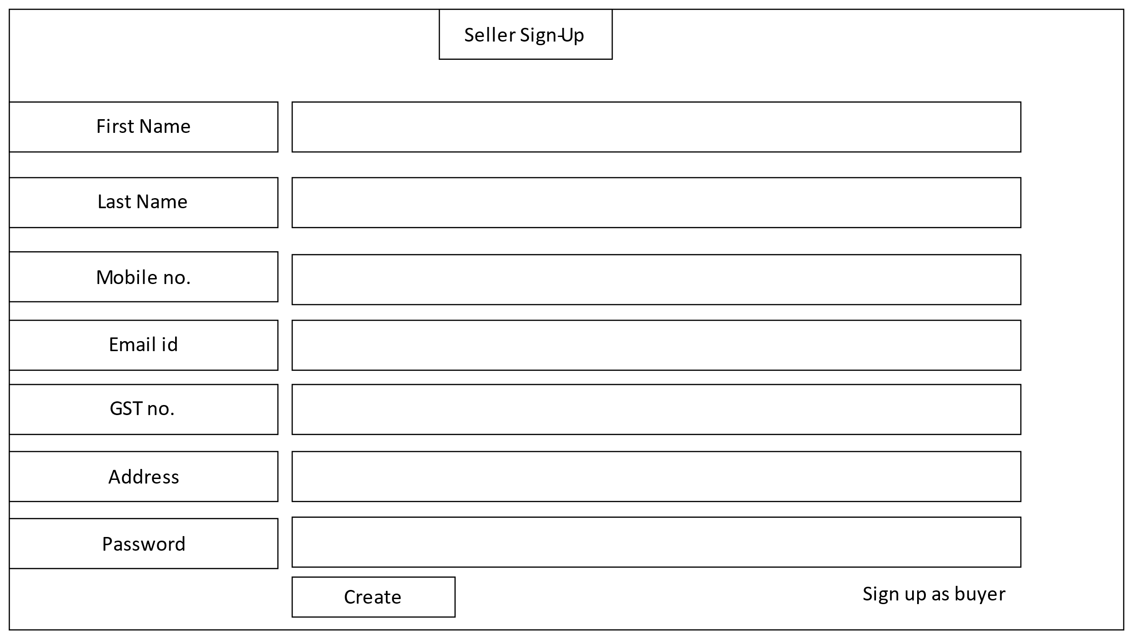

**User Login page**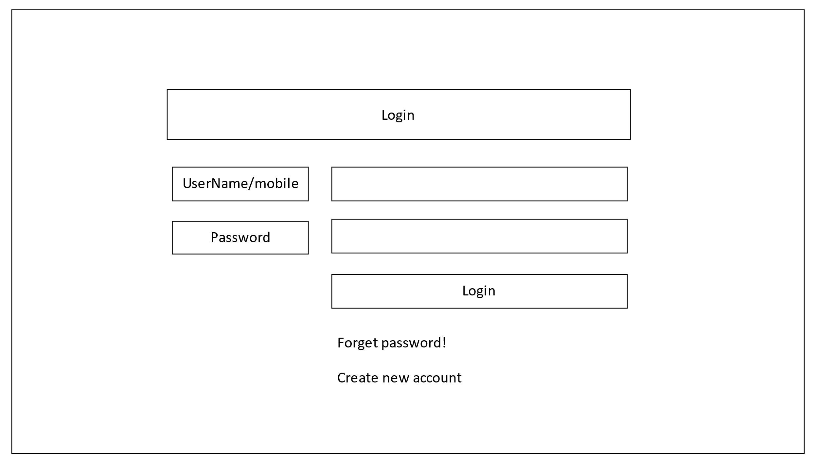

**Add or edit Item:** item details will be entered by default in case of edit item, and can be edited.

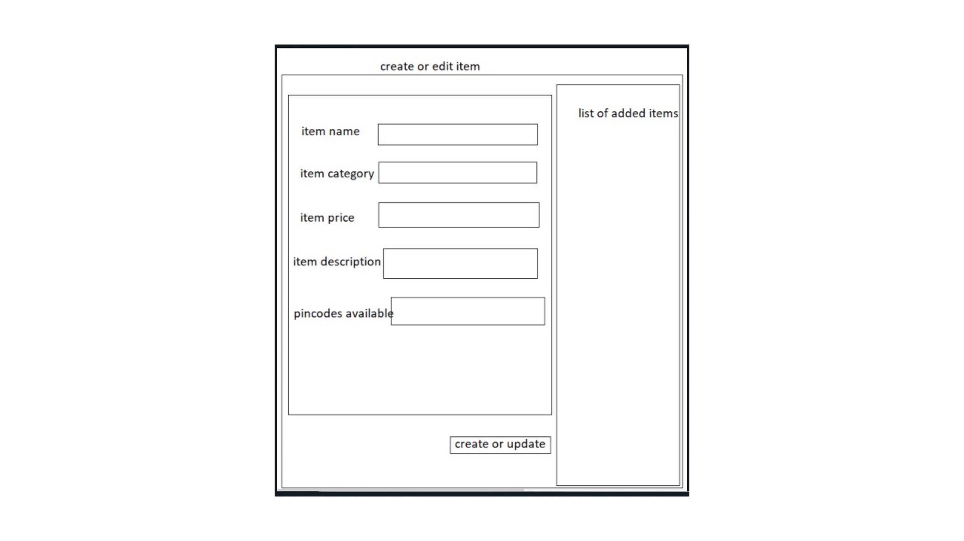

**Home page-** Default page for guest users. 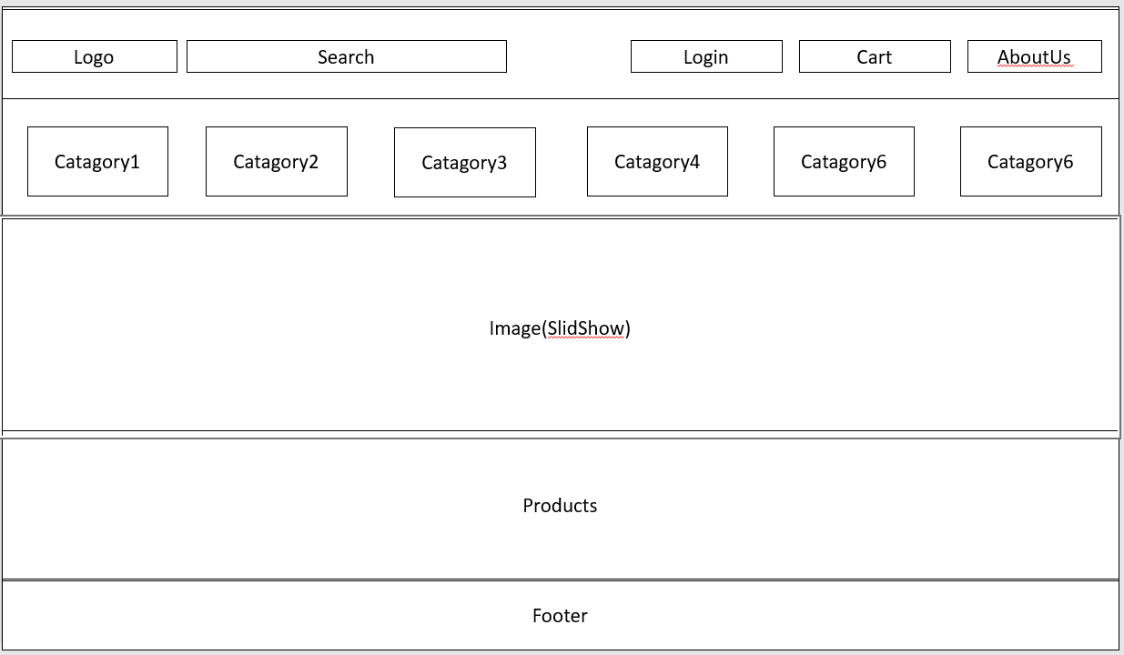

**User Profile page**

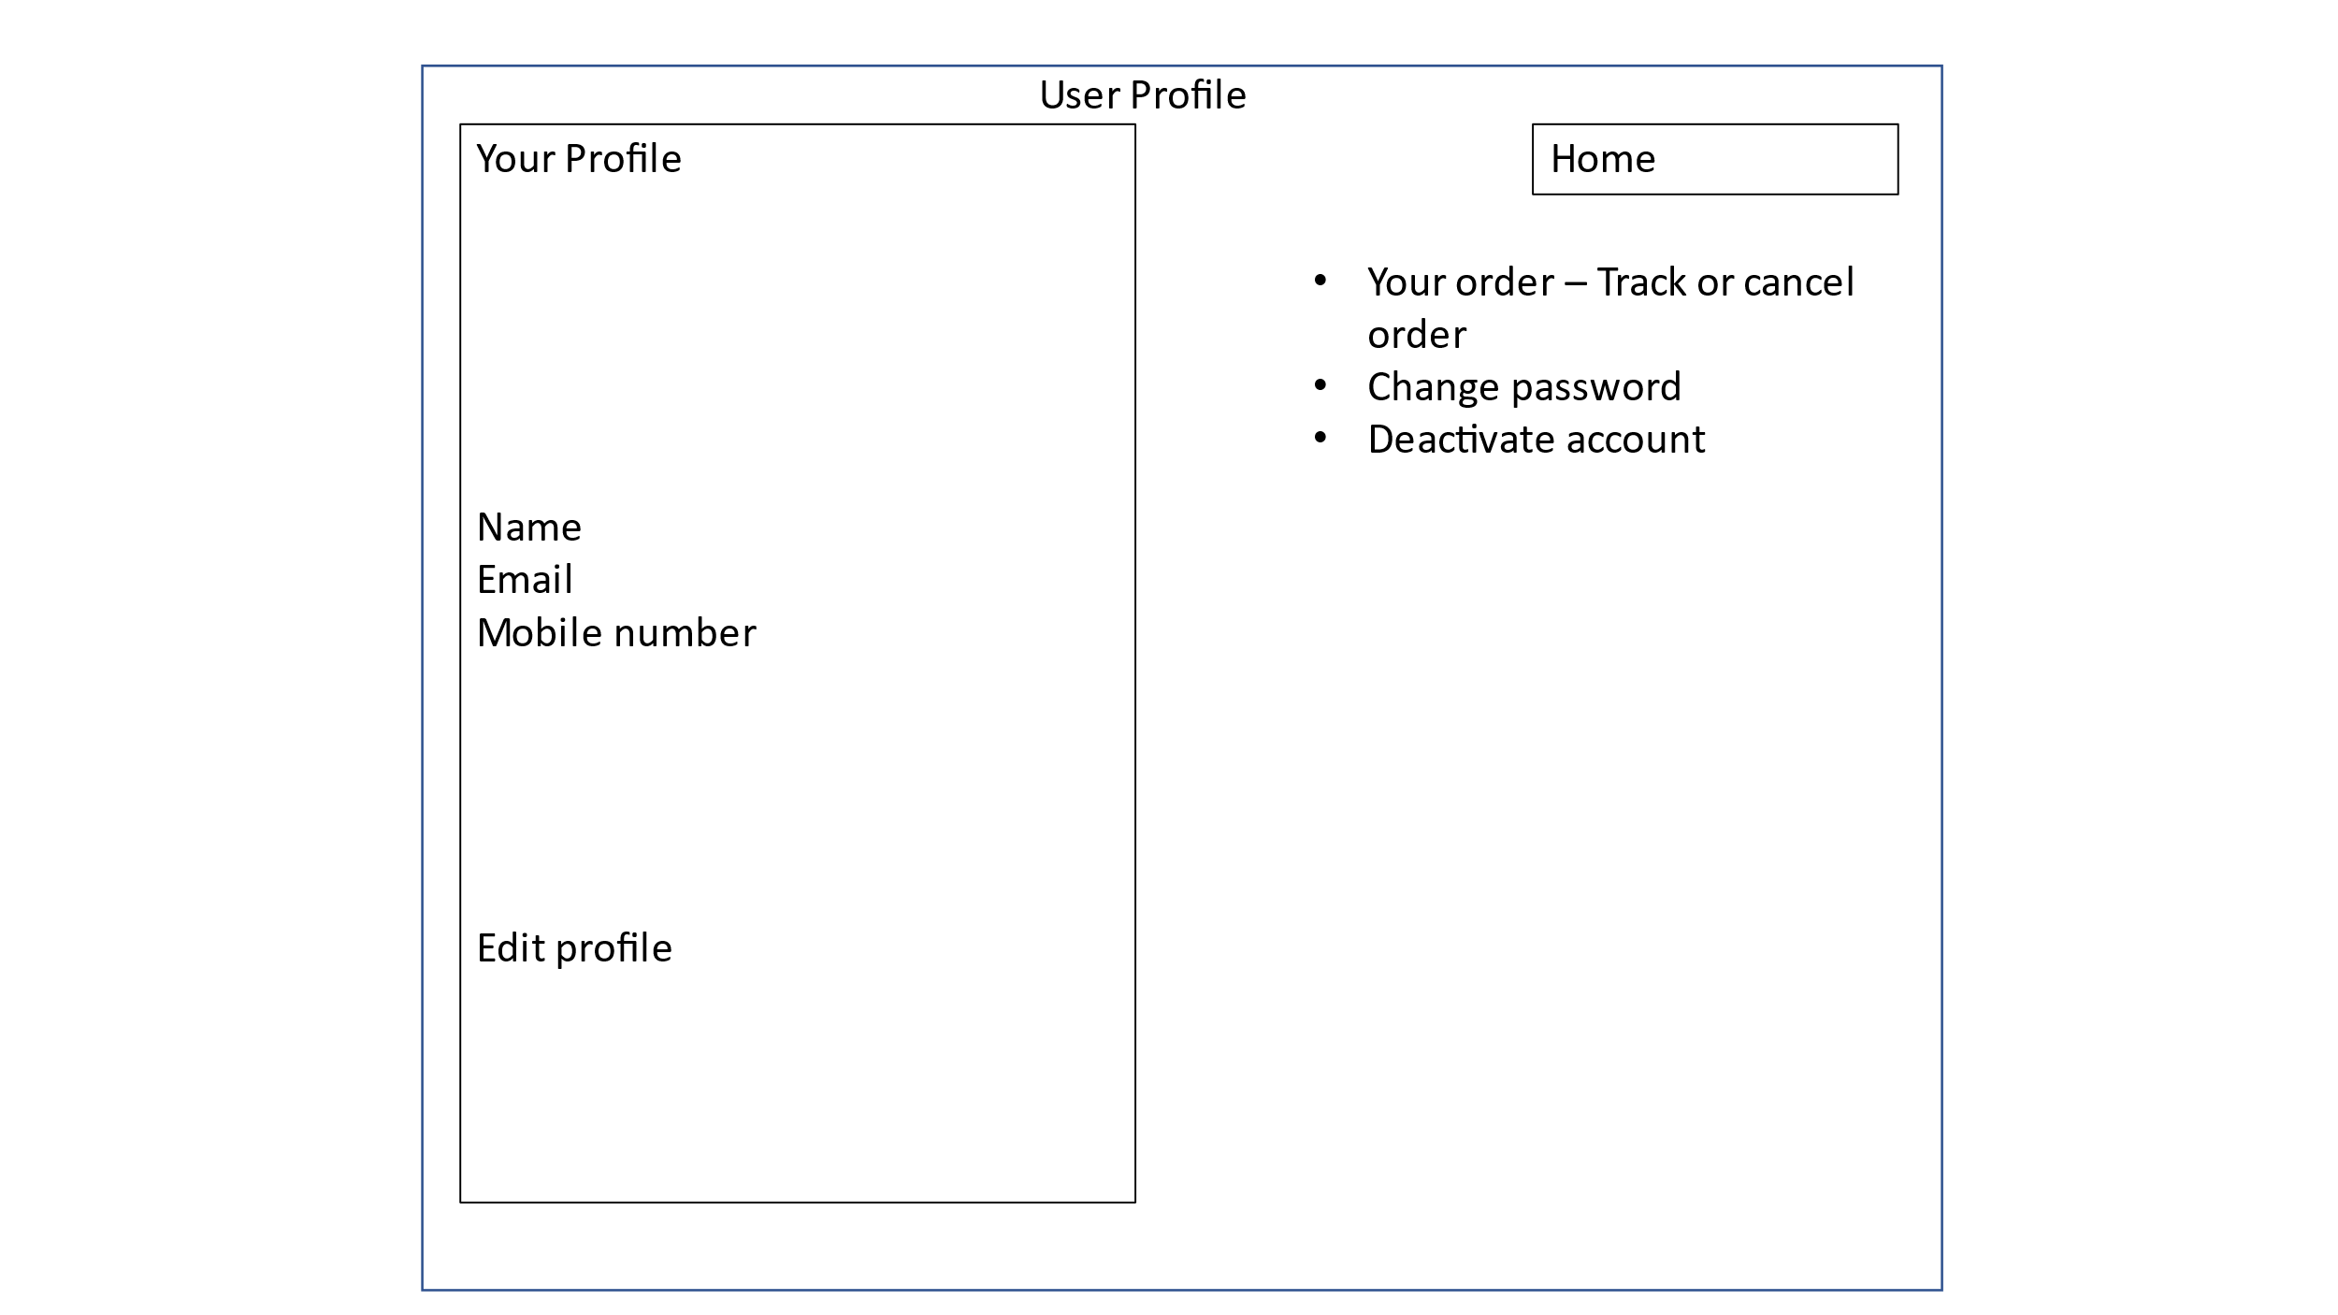

**User’s Your order page**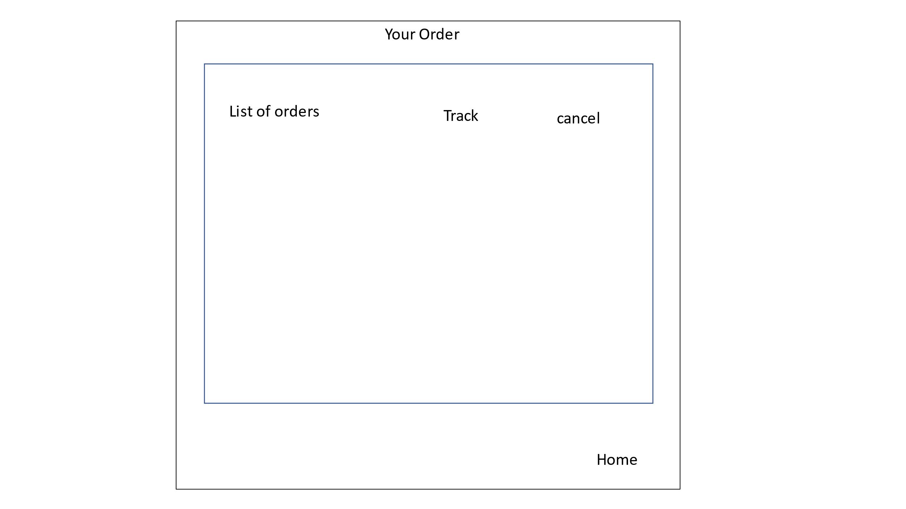

**Cart Page:** After clicking add to cart button below the items, the item will be added to cart, here user can confirm the items to be purchased.

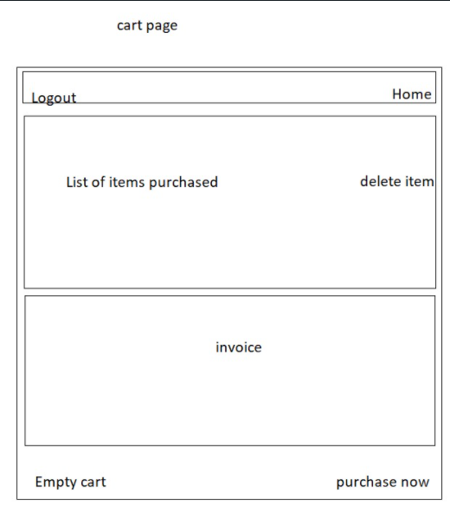

**Payment and Delivery details page**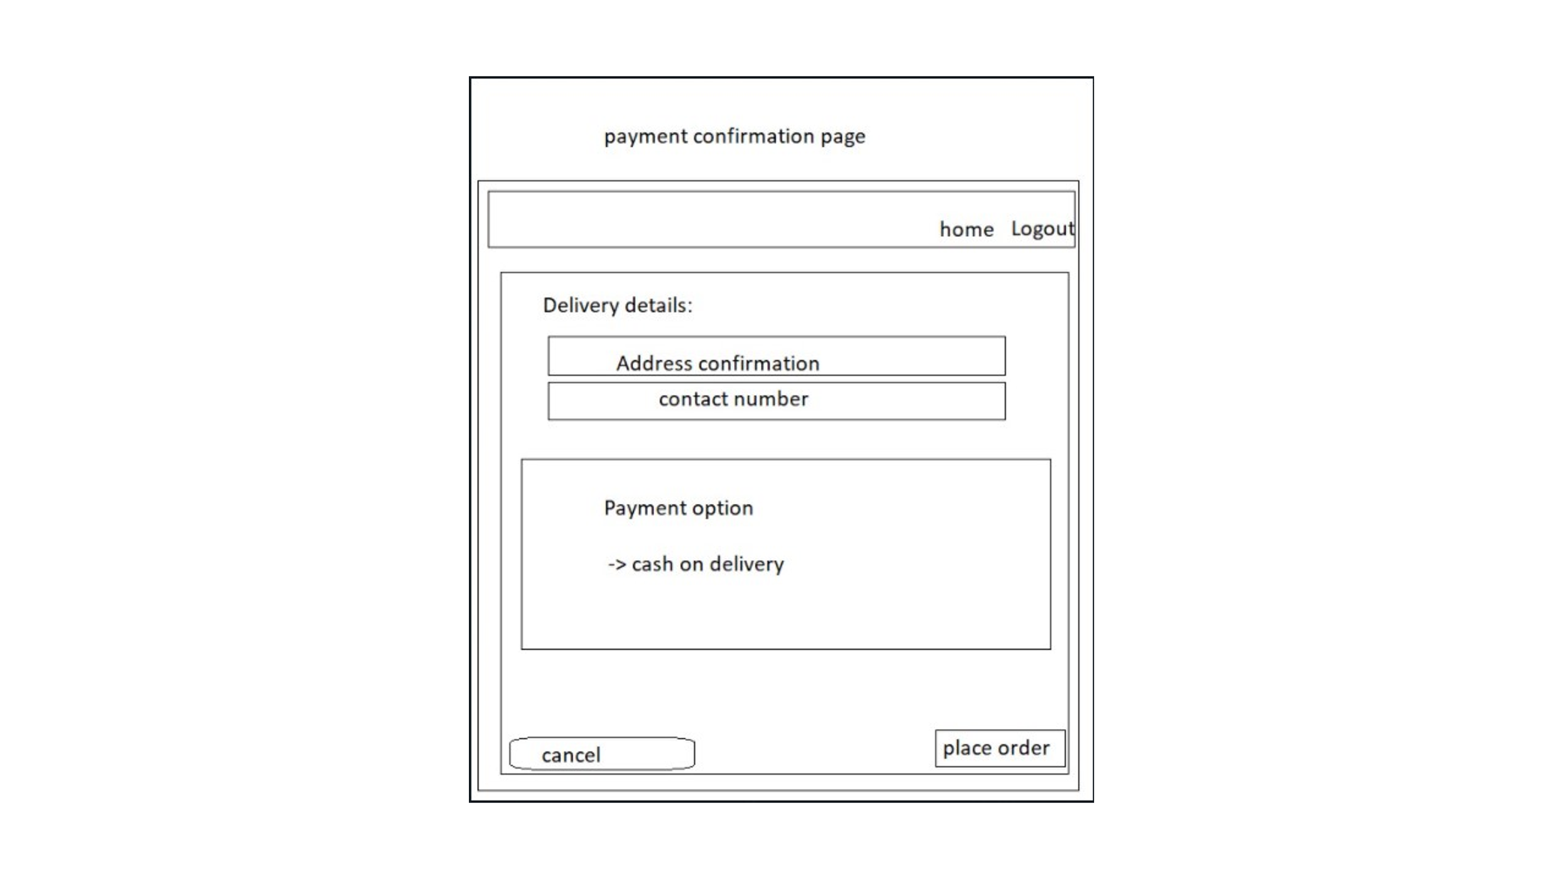

**Admin page:** after login as admin.

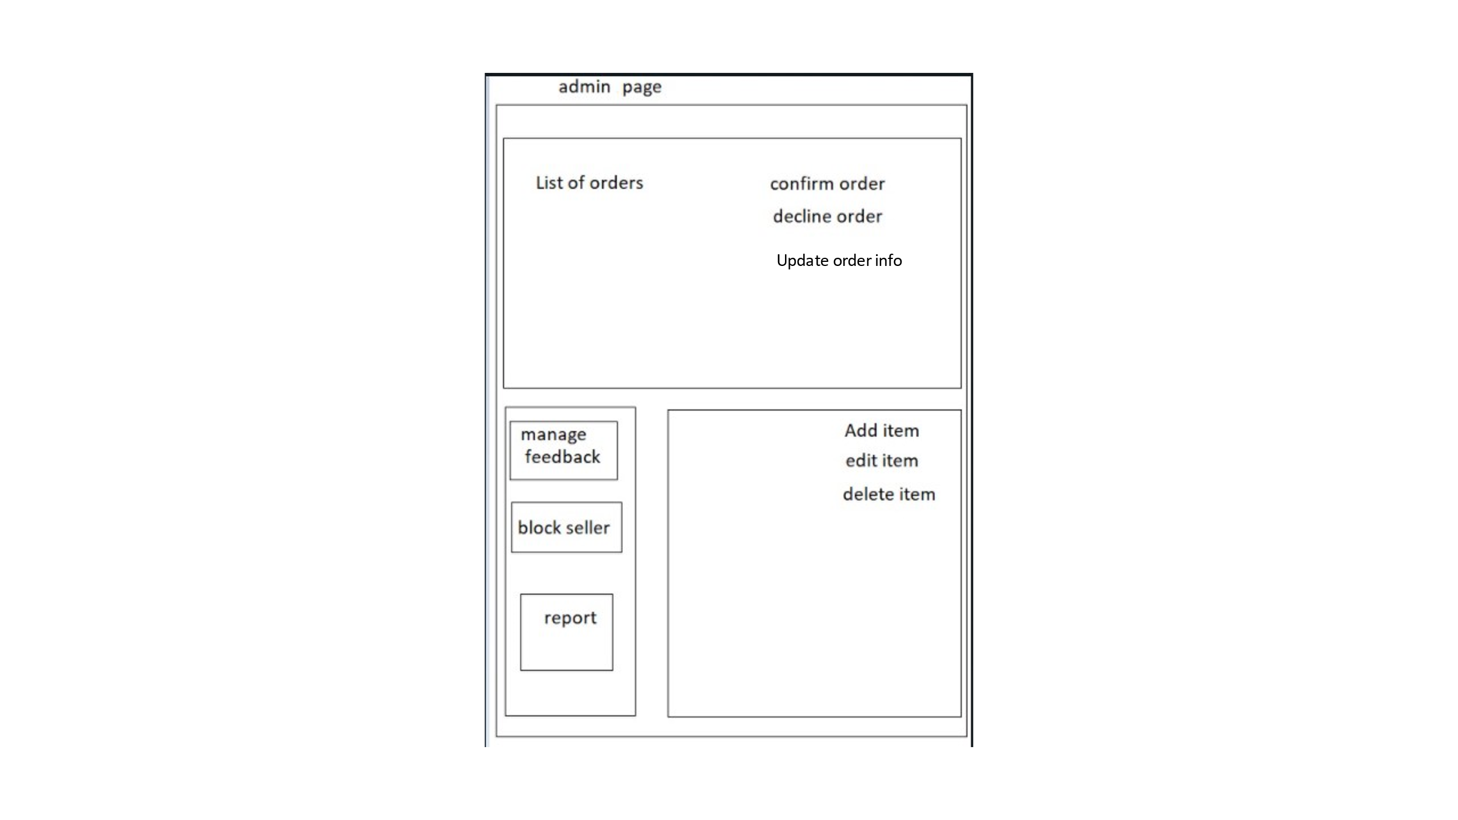

**Seller Page:** After login as seller.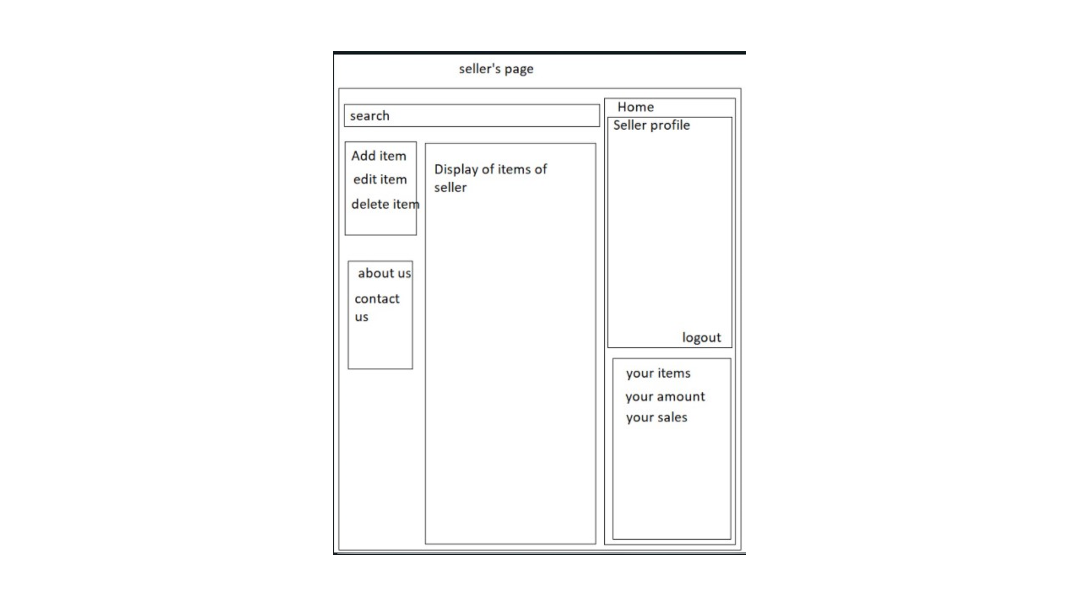

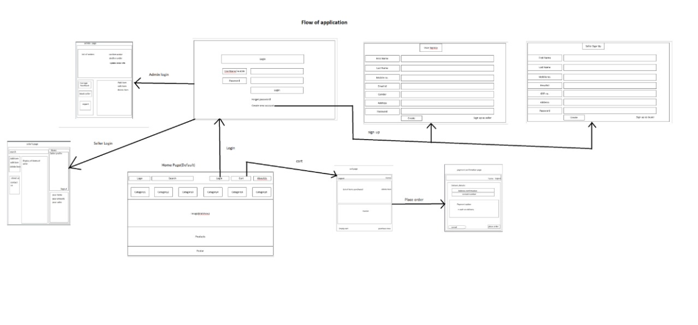

**Flow chart of the Features:**



        
        
        
        